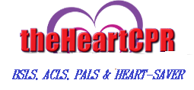 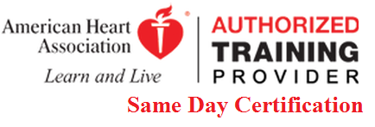 CALL 646 667-5163 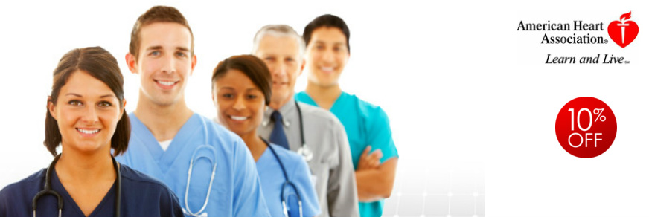
CPR Training done daily by a Registered Nurse (RN/BSN) with twenty years of clinical experience in nursing, we offer BLS, ACLS Heart Saver, AED, and First Aide training at a reasonable price. All Instructors are certified by the American Heart Association (AHA). We are open seven days a week and have flexible schedule to meet your needs!
Call: 646 667-5163
Info@theheartcpr.com
94-18 110 Street
Richmond Hill NY11419
Visit us on the web http://www.theheartcpr.com/

Learn CPR! ON SITE TRAINING DONE AT YOUR LOCATION

