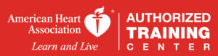

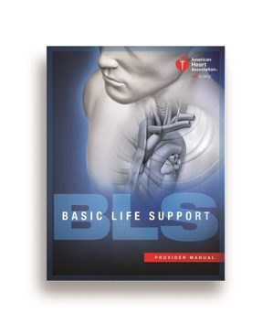
Students Learning Outcome for BLS Course (SLO): At the completion of this course, students will be able to demonstrate and verbalized the following:
Course Costs: $80.00 for Original and Renewal $75.00 with Manuel
• Discuss scene safety and shooting for help
• Demonstrate how to check responsiveness
• Verbalized how to activate emergency response system
• Demonstrate palpating carotid pulse for < 10 sec
• Demonstrate 30 compressions and five cycles
• Demonstrate two breaths using a pocket mask with a one-way valve
• Demonstrate how to open the airway using the head- tilt chin lift technique
• Demonstrate proper use of a bag-mask device
• Demonstrate to use an automatic external defribalator safely
• Verbalize safety precautions using an AED
• Demonstrate child CPR
• Demonstrate infant CPR
• Demonstrate proper technique for choking

